LoginScenario_TestForMarineValidLogin_Instance1_03-Jul-2017_02-46-10_AM_Enter_user_credentials.png

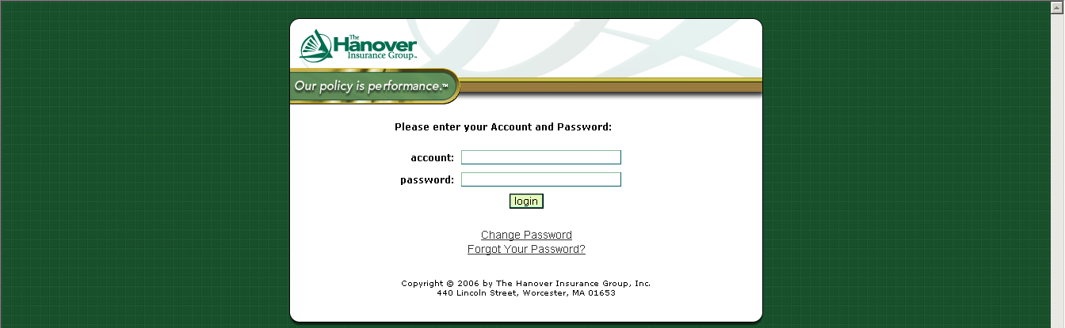

LoginScenario_TestForMarineValidLogin_Instance1_03-Jul-2017_02-46-20_AM_Error.png

